Docker Desktop Setup Guide
OFFLINE CAPABILITIES: Contingency Deployment: Designed for venues where WSL is unavailable, but Docker Desktop app can execute freely.
Zero Internet Check: Transfer container archive using USB drives if local Wi-Fi is restricted.

Contextual Layout Alignment for Docker Diagnostics
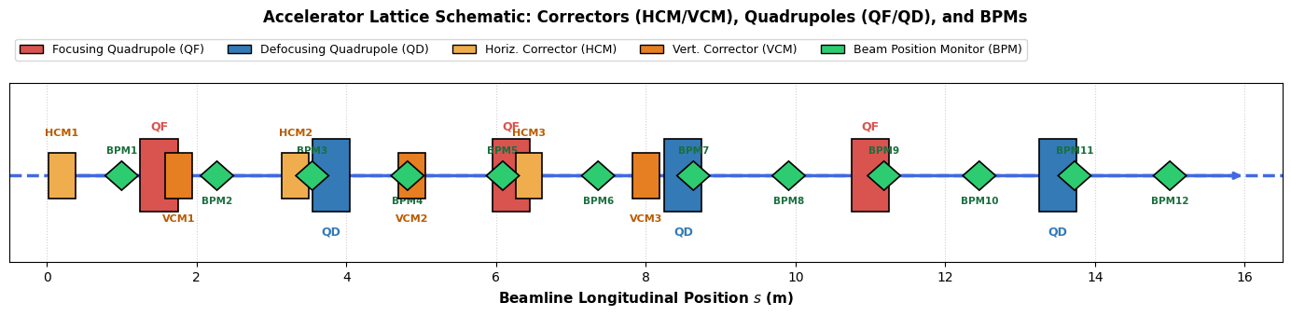
Container Environment Blueprint: Simulates hardware behavior mapping and diagnostic monitors.

PowerShell Setup CLI Command
docker run -it --rm `
-p 8888:8888 `
-v "${PWD}:/home/jovyan/work" `
-e JUPYTER_ENABLE_LAB=yes `
quay.io/jupyter/scipy-notebook:latest

